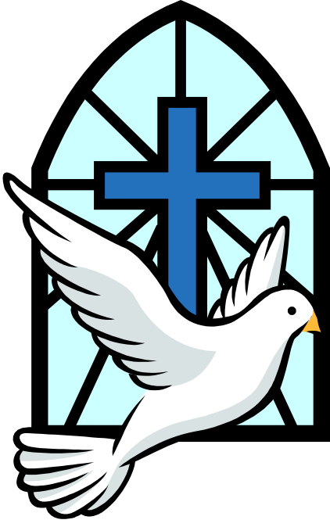

Rosena Edmonds

6 December 1920 – 12 February 2012

Friday 2nd March 2012

Order of Service

The procession enters to The Day thou gavest Please sit once the family are seated.

Introduction

All: Merciful Father, hear our prayers and comfort us; renew our trust in your Son, whom you raised from the dead; strengthen our faith that all who have died in the love of Christ will share in his resurrection; who lives and reigns with you, in the unity of the Holy Spirit, one God, now and for ever. Amen

The Ministry of the Word

Hymn: ‘The King of love my shepherd is’

The King of love my shepherd is,
whose goodness faileth never;
I nothing lack if I am his
and he is mine for ever.

Where streams of living water flow
my ransomed soul he leadeth,
and where the verdant pastures grow
with food celestial feedeth.

Perverse and foolish oft I strayed,
but yet in love he sought me,
and on his shoulder gently laid,
and home rejoicing brought me.

In death's dark vale I fear no ill
with thee dear Lord beside me;
thy rod and staff my comfort still,
thy cross before to guide me.

Thou spread'st a table in my sight;
thy unction grace bestoweth;
and O what transport of delight
from thy pure chalice floweth!

And so through all the length of days
thy goodness faileth never:
good Shepherd, may I sing thy praise
within thy house for ever.

The Scriptural Reading (Revelation 21. 1-7)

Then I saw “a new heaven and a new earth,” for the first heaven and the first earth had passed away, and there was no longer any sea. I saw the Holy City, the new Jerusalem, coming down out of heaven from God, prepared as a bride beautifully dressed for her husband. And I heard a loud voice from the throne saying, “Look! God’s dwelling place is now among the people, and he will dwell with them. They will be his people, and God himself will be with them and be their God. ‘He will wipe every tear from their eyes. There will be no more death’ or mourning or crying or pain, for the old order of things has passed away.” He who was seated on the throne said, “I am making everything new!” Then he said, “Write this down, for these words are trustworthy and true.” He said to me: “It is done. I am the Alpha and the Omega, the Beginning and the End. To the thirsty I will give water without cost from the spring of the water of life. Those who are victorious will inherit all this, and I will be their God and they will be my children.

This is the word of the Lord
All: Thanks be to God

The Address

Reflection: “The Holy City”

The Prayers:

Each section concludes:
Lord, in your mercy
All: hear our prayer.

After the final section:

God of mercy, entrusting into your hands all that you have made and rejoicing in our communion with all your faithful people, we make our prayers through Jesus Christ our Saviour. Amen.

The Lord’s Prayer

All: Our Father, who art in heaven, hallowed be thy name; thy kingdom come; thy will be done; on earth as it is in heaven. Give us this day our daily bread. And forgive us our trespasses, as we forgive those who trespass against us. And lead us not into temptation; but deliver us from evil. For thine is the kingdom, the power and the glory, for ever and ever. Amen

Commendation and Farewell

Time to say goodbye sung by Sarah Brightman

All: Heavenly Father, in your Son Jesus Christ you have given us a true faith and a sure hope. Strengthen this faith and hope in us all our days, that we may live as those who believe in the communion of saints, the forgiveness of sins and the resurrection to eternal life; through Jesus Christ our Lord. Amen.

Blessing

Final music: “Abide with me”

Acknowledgement: Common Worship: Pastoral Services, material from which is included in this service, is copyright © The Archbishops’ Council (2000)

